**Employee Timesheet Tracker**

**Database Project Documentation**

By:

FRANZ LLOYD A. DIAZ

ARJONEL M. MENDOZA, MIT

Lecturer

**PROJECT OVERVIEW**

The Employee Timesheet Tracker is a system designed to record and manage employee

work hours by tracking their clock-in and clock-out times. It aims to streamline attendance

management, improve productivity monitoring, and ensure accurate payroll processing. This

system was created by using Python, CustomTkinter, and MySQL.

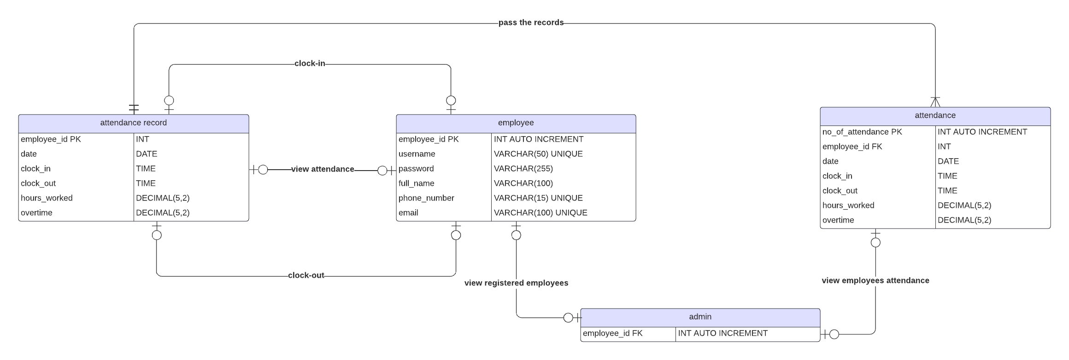**ENTITY-RELATIONSHIP DIAGRAM (ERD)**

*Figure 1. Entity Relationship Diagram*

**Entities and their Relationship Diagram**

1. **employee & attendance record:**

* **clock-in (optional 1 to optional 1) –** An employee can clock-in once per day in
* his/her attendance. Attendance record can be clocked in per employee once in a day.
* **clock-out (optional 1 to optional 1) –** An employee can clock-out once per day in his/her attendance if and only if the employee clocked in. Attendance record can be clocked out per employee once in a day.
* **view attendance (optional 1 to optional 1) -** An employee can view his/her attendance. Attendance record can be viewed per employee.

1. **attendance record & attendance:**

* **pass the records (mandatory one to mandatory many) –** Attendance record must pass the records to attendance. Attendance can accept many attendance records.

1. **admin & attendance:**

* **view employee’s attendance –** Admin can view the attendance of all employees. Attendance can be viewed by one and only one admin.

1. **admin & employee**

* **view registered employees –** Admin can view all registered employees. Employees can be viewed by one and only one admin.

**SQL SCRIPTS**

* Create Database:

**CREATE DATABASE timesheet;**

* Use the database created named ‘timesheet’:

**USE timesheet;**

* Create Tables:

**CREATE TABLE employees**

**(employee_id INT(11) AUTO_INCREMENT PRIMARY KEY,**

**username VARCHAR(50) NOT NULL,**

**password VARCHAR(255) NOT NULL,**

**full_name VARCHAR(100) NOT NULL,**

**phone_number VARCHAR(15) NOT NULL,**

**email VARCHAR(100) NOT NULL**

**);**

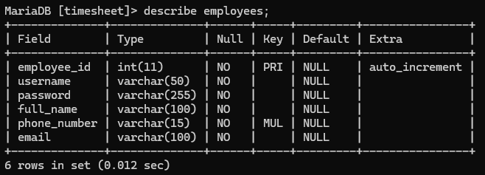

**CREATE TABLE attendance (**

**no_of_attendance INT(100) AUTO_INCREMENT PRIMARY KEY,**

**FOREIGN KEY (employee_id) REFERENCES employee(employee_id),**

**date DATE NOT NULL,**

**clock_in TIME NOT NULL,**

**clock_out TIME NOT NULL,**

**hours_worked DECIMAL(5,2) NOT NULL,**

**overtime DECIMAL(5,2) NOT NULL**

**);**

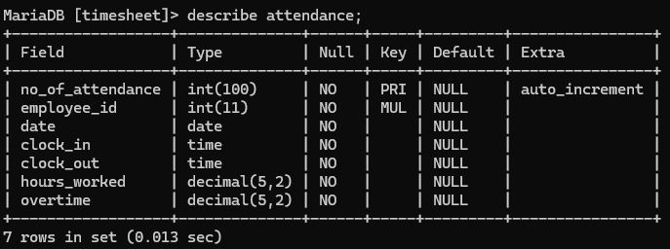

* ‘attendance’ table records:

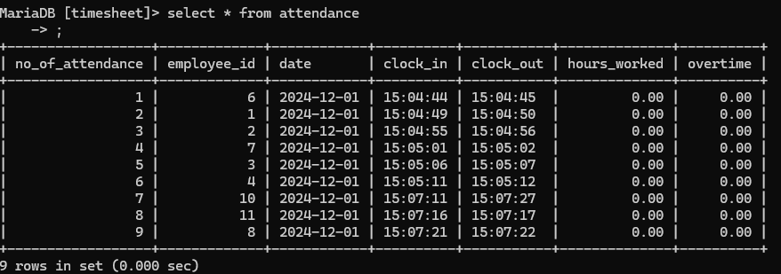

* ‘employees’ table records:

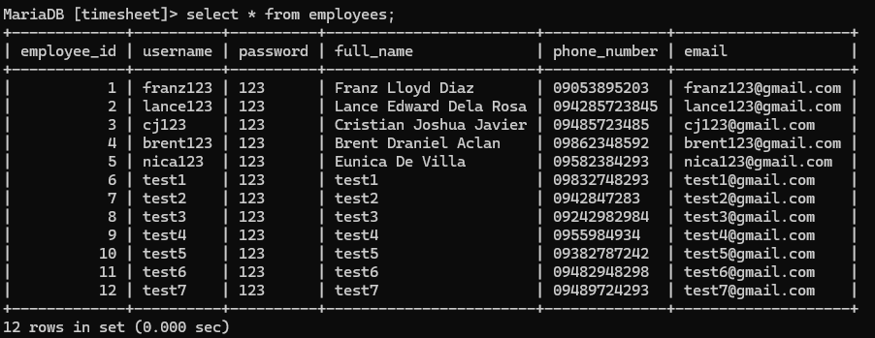

**CODE SNIPPETS**

* connection of MySQL & python

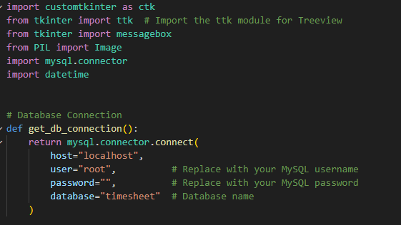

* authentication of employee login

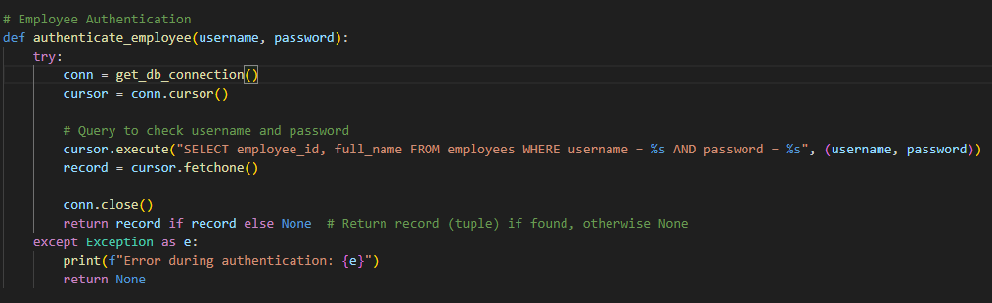

* clock-in function

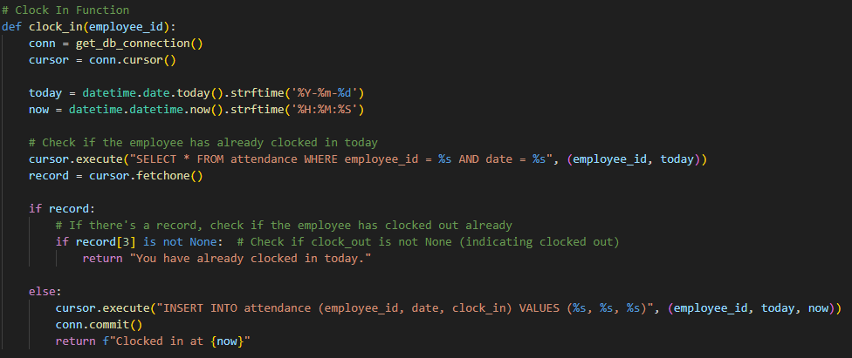

* clock-out function

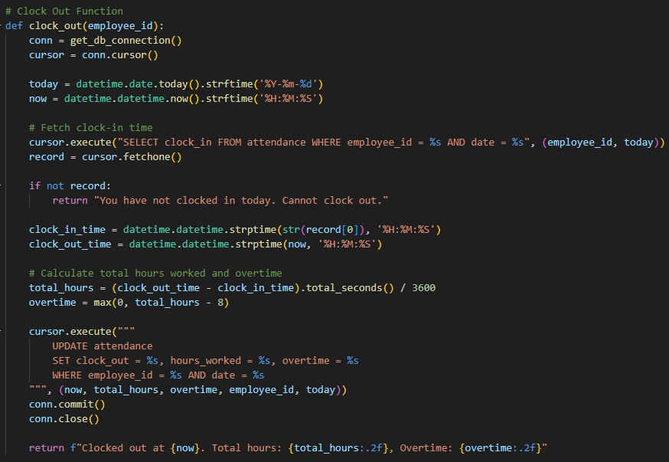

* get the attendance of the logged-in employee

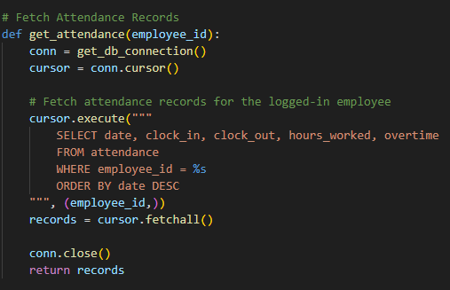

* register employee

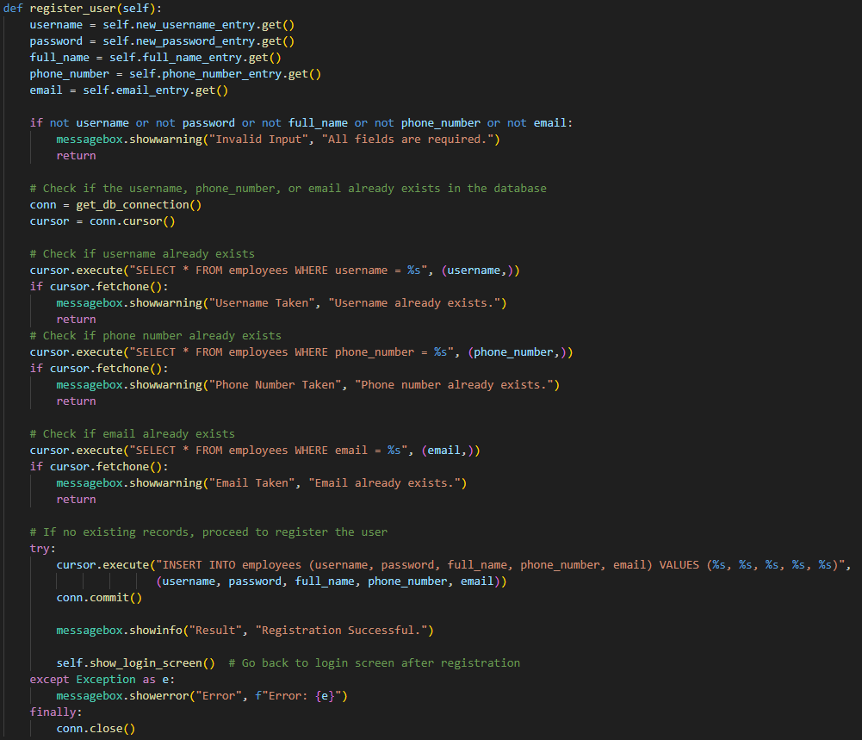

* in admin mode, show all attendance records

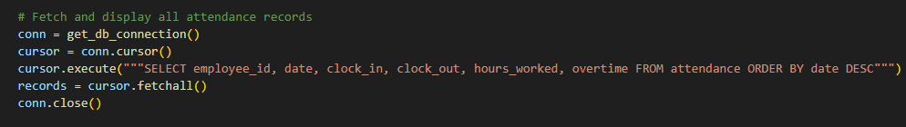

* in admin mode, show all registered employees

